 | Project Progress Report FYP-I
 | COMSATS University Islamabad – Lahore Campus
 | DEPARTMENT OF COMPUTER ENGINEERING

FYP-I Project Progress Report

Project Title

Project Supervisor

Group Members | Student’s Name | Student’s Reg. ID | Student’s Email Address

Comments about the Group and the Project Scope:

Co-supervisor (if any)  Signatures: _____________________________  Name: _________________________________  Date: __________________________________  (Checked and Signed by the Co-Supervisor) | Supervisor  Signatures: _____________________________  Name: _________________________________  Date: __________________________________  (Checked and Signed by the Supervisor)

Page intentionally left blank

Table of Contents

1 Introduction 1
1.1 Historical Background 1
1.2 Objectives and Limitations 1
1.3 Project Scope 1
1.4 Assumptions and Dependencies 1
1.5 Broader Impact (UN SDGs) 2
1.6 Thesis Key Contributions 2
1.6.1 Thesis Outline 2
2 Literature Review 5
3 Modeling and Simulation 7
3.1 Conceptual Framework 7
3.2 High Level Design 7
3.3 Subsystem Design 7
3.4 Low Level Design and Component Selection 7
3.5 Heading Level 2 9
3.5.1 Subheading Level 3 10
4 Hardware/Software Implementation and Testing 11
4.1 Development Stages 11
4.1.1 Component 1 11
4.1.2 Component 2 11
4.2 User Interface 11
4.2.1 UI Component 1 11
4.3 Evaluation 12
4.4 Unit Testing 12
4.5 Function Testing 12
4.5.1 Testing Requirements < A, B, C> 12
4.5.2 Testing Requirements < A, B, C> 12
5 Results and Discussion 13
5.1 Results of Development Stage 1 [Impact of …] 13
5.2 Results of Development Stage 2[Effect of …] 13
5.3 Comparison [Preferably separate or included in discussion] 13
5.4 Socio-Economic and Environmental Impact of the Project 13
6 Conclusions and Future Work 15
6.1 Idea 1 15
6.2 Idea 2 15
6.3 Idea 3 15
Appendixes 17
Appendix A: Sustainable Development Goals Achievement 17
Appendix B: HDL or C Source Code 20
Appendix C: Hardware Schematics 21
Appendix D: List of Components 22
Appendix E: Project Timeline 23
Bibliography 25

List of Symbols, Abbreviations and Acronyms

ROC Region of Convergence
FAR False Acceptance Rate
FRR False Rejection Rate
ERR Equal Error Rate

List of Figures

Figure 2. 1 An Example of inserting Figure into your project 5

Figure 3. 1 Example Figure for Prototype Application 8
Figure 3. 2 Architecture Overview Diagram 9

Figure 4. 1 Example Figure for User Interface 12

List of Tables

Table 1. 1 SDGs in the light of your objectives 2

Table 2. 1 abc 6

Table 3. 1 lmn 8

Abstract
The abstract must briefly present the objective, methodology, key results, and conclusion of the study. It should be clear, concise, and self-contained, without the use of references, figures, tables, or equations. The font must be Times New Roman, with a font size of 12 points and non-italic font style. The text alignment may follow the document standard (recommended: justified). The line spacing must be set to single (1.5). The paragraph spacing before must be 0 points, and the paragraph spacing after must also be 6.0 points. Consistent formatting must be maintained throughout the abstract. In addition, the main document must ensure that the List of Acronyms, List of Figures, and List of Tables are clearly included and properly mentioned in the Table of Contents.
This is second paragraph if needed.

Introduction
Instruction only (remove this para from the thesis): Please note that new chapter must start on odd page number, for example this chapter (chapter 1) starts at page number 1 ( 1 ODD). You may need to add blank page stating: Page intentionally left blank. In printed bound copy, odd page numbers will be observed on the right side.
This is one of the most important components of the report. It should begin with a clear statement of what the project is about so that the nature and scope of the project can be understood by a lay reader. It should summarize everything you set out to achieve, provide a clear summary of the project's background, relevance and main contributions. The introduction should set the scene for the project and should provide the reader with a summary of the key things to look out for in the remainder of the report.
- The introduction itself should be largely non-technical.
- It is sometimes useful to state the main objectives of the project as part of the introduction.
- Concentrate on the big issues, e.g. the main questions (scientific or otherwise) that the project sets out to answer.

Historical Background
Explain historical perspective or background of the work if there is any…

Objectives and Limitations
The main goal of the project is to investigate …
The research includes devising possible improvements in …
The project includes development of hardware to …
The project includes development of software to …
The

Project Scope
The …

Assumptions and Dependencies
The …

Broader Impact (UN SDGs)
Instruction only (remove this para from the thesis): Write a detailed description on how your project lies under certain SDGs in the light of your objectives, solutions, and obtained results. Give examples where appropriate.

Table 1. 1 SDGs in the light of your objectives
SDGs | Included/ Not Included | If Included Inclusion Level as: Partial, Average, or Major | Goal (s) of Project that Lie in the SDG | How goal (s) meet the criteria for SDG | Additional Remarks/ Discussions
SDG 3: Good Health and Well-being
SDG 4: Quality Education
SDG 8: Decent Work and Economic Growth
SDG 9: Industry, Innovation, and Infrastructure
SDG 11: Sustainable Cities and Communities
SDG 12: Responsible Consumption and Production

Thesis Key Contributions
This thesis contributes to two aspects of …

Thesis Outline
This thesis continues with the following chapters

Chapter 2 covers the background material and literature reviewed to understand the intricacies of …
Chapter 3 gives model and simulation …
Chapter 4 explains hardware and software implementation …
Chapter 5 discusses and compares results with …
Chapter 6 concludes …

In the end, we briefly present the conclusions from this project and also the possible future improvements and additions for better design/implementation and investigation of <PROJECT NAME>.

Page intentionally left blank

Literature Review
Instruction only (remove this para from the thesis): Please note that new chapter must start on odd page number, for example this chapter (chapter 2) starts at page number 5 ( 5 ODD). You may need to add blank page stating: Page intentionally left blank. In printed bound copy, odd page numbers will be observed on the right side.
The background section of the report should set the project into context by relating it to existing published work which you read at the start of the project when your approach and methods were being considered. There are usually many ways of solving a given problem, and you shouldn't just pick one at random. Describe and evaluate as many alternative approaches as possible.
The background section can be included as part of the introduction but is usually better as a separate chapter, especially if the project involved significant amount of prior research. The published work may be in the form of research papers, articles, text books, technical manuals, or even existing software or hardware of which you have had hands-on experience. ….Use Mendeley Reference Management Software. [1].
Please Note that all references are managed using Mendeley, and the in-text numbers link to the full reference entries below. Clicking a number will take the reader directly to the corresponding reference.

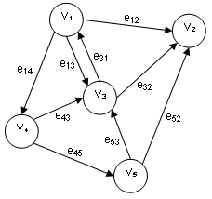
Figure 2. 1 An Example of inserting Figure into your project

Its WARNING: Avoid plagiarism … If you take another person's work as your own and do not cite your sources of information you are being dishonest; in other words you are cheating. When referring to other pieces of work, cite the sources where they are referred to or used, rather than just listing them at the end.

Table 2. 1 abc

Modeling and Simulation
Instruction only (remove this para from the thesis): Please note that new chapter must start on odd page number, for example this chapter (chapter 3) starts at page number 7 ( 7 ODD). You may need to add blank page stating: Page intentionally left blank. In printed bound copy, odd page numbers will be observed on the right side.

Conceptual Framework
(Explain the basic technique used to design the project. Elaborate the design philosophy and examples from previous works to justify its viability)

High Level Design
- (Present the High-Level block diagram with inter dependencies, sequence and outputs. Map your objectives, deliverables on the block diagram to ensure the completeness of the project). Explain the block diagram.
- (Present a flow diagram linking all inputs, outputs and decision boxes). Explain the flow diagram)
- Performance target of the system in comparison with contemporary systems
- Calculation of performance parameters including efficiency, sensitivity and any other parameter

Subsystem Design
- List the subsystems clearly as mentioned in the High-Level Design Block diagram and Flow chart
- Draw and explain each subsystem block diagram and flow chart if applicable
- Software Implementation on PC before implementation on Microcontroller
- Working of each subsystem before integration

Low Level Design and Component Selection
- List all the major components used in the project and group them in subsystems as defined in the previous section
- Propose a component and justify its selection for a particular function. Explain its working phenomena and identify multiple options available off the shelf. Describe its viability based on ease of sourcing and price.

A very basic prototype was developed … …

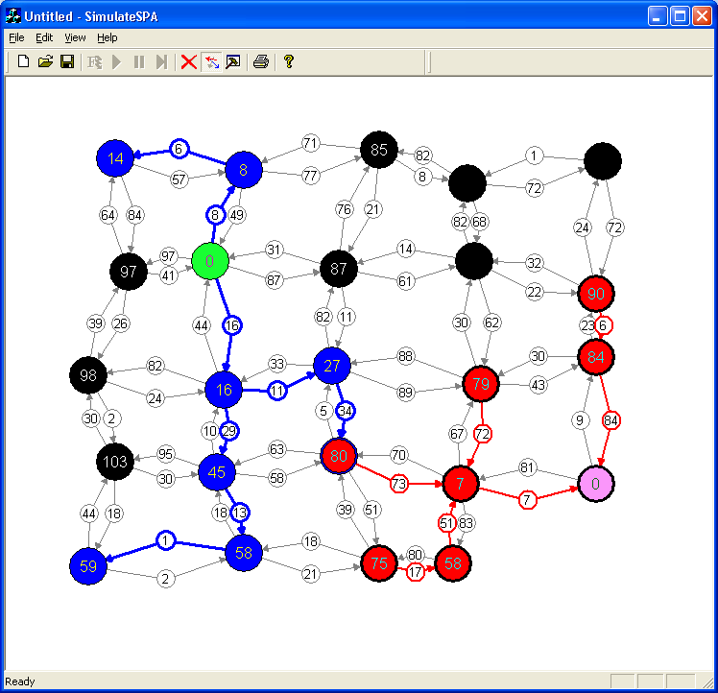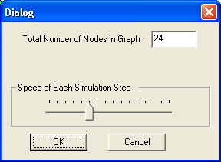
Figure 3. 1 Example Figure for Prototype Application

Table 3. 1 lmn

The …
The …
The …

Heading Level 2
The design of the intended product is explained graphically with the help of a diagram shown in Figure 3.1. The diagram explains the overall interactions of the modules and their placements.

Network
Path Finder
Interface
Network Decomposer
Path Finder Implementers
Network
Serialization
Network
Editing
Network
Generation
Event
Handlers
Graphical User Interface
(GUI)
Nodes

Objects

Nodes
Links
Nodes

Nodes
Zones
(Partition)
Zones
(Partition)
Zones
(Partitions)
Figure 3. 2 Architecture Overview Diagram

Subheading Level 3
Following are the modules constituting the product to be developed. Please note that we are documenting only the salient properties and methods of each module to keep the description simple and more readable.

Hardware/Software Implementation and Testing
Instruction only (remove this para from the thesis): Please note that new chapter must start on odd page number, for example this chapter (chapter 4) starts at page number 11 ( 11 ODD). You may need to add blank page stating: Page intentionally left blank. In printed bound copy, odd page numbers will be observed on the right side.
We have implemented the suggested design using … …

Development Stages
Following were the

Component 1
We have implemented …

Component 2
The …

User Interface
User Interface is an extremely important consideration for any project that requires human-machine interaction. However, this project doesn’t require human machine interaction and therefore the product runs solely in the background without any user input. Besides this fact, we have introduced an option to display the current status, orientation, and power production from the requested solar panels. The user interface is… …

UI Component 1
This figure…
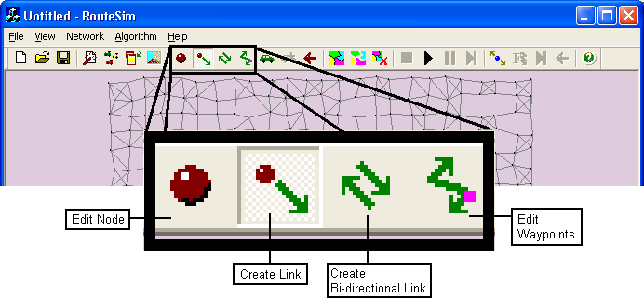
Figure 4. 1 Example Figure for User Interface

Evaluation
This chapter includes the results obtained through the implementation of the suggested design methodology and their detailed discussion …

Unit Testing

Function Testing

Testing Requirements < A, B, C>

Testing Requirements < A, B, C>

Results and Discussion
Following were the …

Results of Development Stage 1 [Impact of …]
We have implemented …

Results of Development Stage 2[Effect of …]
We have …

Comparison [Preferably separate or included in discussion]
We have …

Socio-Economic and Environmental Impact of the Project
We have …

Page intentionally left blank

Conclusions and Future Work
In this project, we have investigated and developed … … …

There could be several improvements possible … Some of the ideas for future development is mentioned below:

Idea 1
…

Idea 2
…

Idea 3
…

Future research actions on the Project to enhance its Social and Environmental Impact

Page intentionally left blank

Appendixes

Appendix A: Sustainable Development Goals Achievement

(Write a detailed description on how your project lie under certain SDGs in the light of your objectives, solutions, and obtained results. Give examples where appropriate)

SDGs | Included/ Not Included | If Included Inclusion Level as: Partial, Average, or Major | Goal (s) of Project that Lie in the SDG | How goal (s) meet the criteria for SDG | Additional Remarks/ Discussions







Appendix B: HDL or C Source Code

Appendix C: Hardware Schematics

Appendix D: List of Components

Appendix E: Project Timeline

DATE

PROJECT ID |  |  |  |  |  | TOTAL NUMBER OF WEEKS IN PLAN
TITLE
No. | STARTING WEEK |  |  | DESCRIPTION OF MILESTONE |  |  | DURATION
1
2
3
4
5
6
7
8
9
10
 |  |  |  | Sum:

* You can provide Gantt chart instead of filling in this form, if you like

Page intentionally left blank

Bibliography
- Ross Sherlock, Peter Mooney, Adam Winstanley & Jan Husdal, "Shortest Path Computation: A Comparative Analysis", GISRUK pp 91-94, Sheffield, UK, April 2002.

- S. Shekhar, M. Coyle, A. Kohli, Path Computation Algorithms for Advanced Traveller Information Systems, IEEE Computer Society, 1993.

- R. Jacob, M. Marathe and K. Nagel, A Computational Study of Routing Algorithms for Realistic Transportation Networks, invited paper appears in ACM J. Experimental Algorithmics, 4, Article 6, 1999. http://www.jea.acm.org/1999/JacobRouting/

- D. Wagner, T. Willhalm and C. D. Zaroliagis; Geometric Shortest Path Containers; Universit¨ at Karlsruhe, Fakult¨ at f¨ ur Informatik 2004-5, 2004.

- John Taplin, Simulation Models of Traffic Flow, Proceeding of the 34th Annual Conference of the Operational Research Society of New Zealand (ORSNZ'99), Keynote Paper, University of Waikato, Hamilton NZ, December 1999, pp 175-184.

- S. Pallottino e M. G. Scutell`a, Shortest path algorithms in transportation models: classical and innovative aspects, In (P. Marcotte and S. Nguyen, eds.) Equilibrium and Advanced Transportation Modelling, Kluwer (1998) 245-281.

- Andrea Díaz, Verónica Vázquez, G. Wainer. "Vehicle routing in Cell-DEVS models of urban traffic". In Proceedings of European Simulation Simulation. Marseille, France. 2001.

- Rong Zhou and Eric A. Hansen, Breadth-First Heuristic Search , 14th International Conference on Automated Planning and Scheduling (ICAPS-04) Whistler, British Columbia, Canada, 2004.

- Jayadev Misra, A walk over the shortest path: Dijkstra's Algorithm viewed as fixed-point computation. Information Processing Letters. Volume 77, Number 2-4, pp 197-200. February 2001.

- Matthias Schmidt, "Decomposition of a Traffic Flow Model for a Parallel Simulation", Proc. AI, Simulation and Planning in High Autonomy Systems (AIS2000), March 6-8, 2000, Tucson, USA, pp 199-202

- KLD Associates Inc. (last accessed on April, 2004). http://www.kldassociates.com/

- Peytchev E., Bargiela A., Parallel simulation of city traffic using PADSIM, Proceedings of Modelling and Simulation Conference ESM'95, Prague, Eds. M Snorek, M Sujansky, A Verbraeck, June 1995, ISBN 1-56555-080-3, pp. 330-334.

- Oscar Franzese and Shirish Joshi, Traffic Simulation Application to Plan Real-Time Distribution Routes, Proceedings of the 2002 Winter Simulation Conference (WSC), E. Yücesan, C.-H. Chen, J. L. Snowdon, and J. M. Charnes, eds.

- Polly Huang and John Heidemann, Minimizing Routing State for Light-Weight Network Simulation, In Proceedings of the International Symposium on Modeling, Analysis and Simulation of Computer and Telecommunication Systems, p. to appear. Cincinnati, Ohio, USA, IEEE. August, 2001. http://www.isi.edu/~johnh/PAPERS/Huang01b.html

- Yu Jiangsheng, Lecture on Single-Source Shortest Paths, Institute of Computational Linguistics, Peking University, 2003

- Baruch Awerbuch , Bonnie Berger , Lenore Cowen , David Peleg, Near-Linear Time Construction of Sparse Neighborhood Covers, SIAM Journal on Computing, v.28 n.1, p.263-277, Feb. 1999

- Vittorio Astarita, Vincenzo Punzo, Vincenzo Torrieri, Calibration and Comparison Of Simulation Models For Road Network Planning: The Congested Network Of Pozzuoli, 9th Meeting of the Euro Working Group on Transportation, Bari, Italy, June 2002.

- M.Herty And A.Klar, “Modeling, Simulation,And Optimization Of Traffic Flow Networks”, SIAM Journal On Scientific Computing Volume 25, Number 3 Pp. 1066-1087

- Andrew V. Goldberg and Craig Silverstein, Implementation of Dijkstra’s Algorithm Based on Multi-Level Buckets, Technical Report 95-187, NEC Research Institute, Princeton, NJ, 1995

- Ariel Orda and Raphael Rom, "Shortest path and minimum-delay protocols in networks with time-dependent edge-length", Journals of the ACM, Volume 37, Issue 3, pp 607-625, 1990, ISSN:0004-5411

- A. Orda and R. Rom. Shortest-path and minimum-delay algorithms in networks with time-dependent edge-length. Journal of the ACM, 37(3):607--625, 1990.

- Hermann Kaindl and Gerhard Kainz. Bidirectional heuristic search reconsidered. Journal of Artificial Intelligence Research, 7:283--317, 1997.

- D. Wagner, T. Willhalm, C. Zaroliagis. Dynamic shortest path containers. Alberto Marchetti-Spaccamela, Proc. Algorithmic Methods and Models for Optimization of Railways (ATMOS 2003), Volume 92 of Electronic Notes in Theoretical Computer Science, pages 65-84, 2004.

- P. W. Eklund, S. Kirkby, and S. Pollitt, A Dynamic Multi-source Dijkstra’s Algorithm for Vehicle Routing, IEEE Transactions, Proceeding 1996 Australian New Zealand Conference on Intelligent Information Systems, 18-20 November 1996, Adelaide, Australia.

- Öjvind Johansson. Graph decomposition using node labels. PhD thesis, Royal Institute of Technology, Stockholm, 2001.

